* 1. **I can investigate a range of development environments**

A development environment is a collection of processes and tools that can be used to develop an application.

Two of the more popular development processes are Agile and Waterfall.

**Waterfall**

The Waterfall modal of application development, as the name suggests, is a series of steps in a waterfall pattern

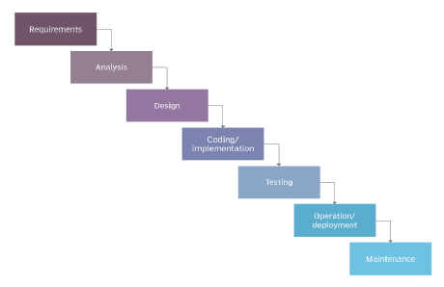

*Above picture sourced from* [*https://www.techtarget.com/searchsoftwarequality/definition/waterfall-model*](https://www.techtarget.com/searchsoftwarequality/definition/waterfall-model)

Of the two methodologies, Waterfall has been in use for several decades. In this modal, coders typically work alone rather than in teams. It can difficult to go back several steps in the process, and this presented difficulties. In some cases bugs or complications discovered in testing can result in costly delays, or the process being scrapped.

**Agile**

Typically used to develop software applications, the process resembles this:

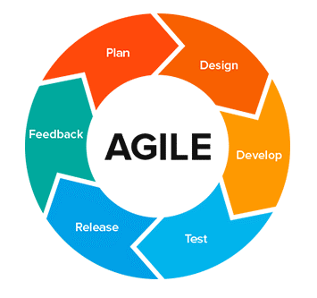

*Above picture sourced from* [*https://medium.com/moodah-pos/agile-development-95cad3573abf*](https://medium.com/moodah-pos/agile-development-95cad3573abf)

The benefits of Agile include that coders rarely work alone, typically working in teams. As a result of this there is more collaboration and tasks are completed much more quickly. In addition if testing finds complications, it is much more simple to revert to planning or design with little to no delays.